Software Requirements Specification

**Ping Using NS3 1.1**

### PREPARED BY

SANKET S KULKARNI[1JT13CS042]

### GUIDED BY

B.I.D Kumar Sir

# 

**Contents**

INTRODUCTION………………………………………………………………………3

1.1 Purpose…………………………………………………………………………….3

1.2 Scope………………………………………………………………………………3

REQUIREMENT SPECIFICATION…………………………………………………...3

2.1 Software requirements……………………………………………………………..3

2.1.1Ping………………………………………………………………………………3

Components of NS3……………………………………………………………………3

2.1.2 NS3……………………………………………………………………………4

2.1.3 IPV6………………………………………………………...4

FUNCTIONAL REQUIREMENTS……………………………………………………..5

OTHER FUNCTIONAL REQUIREMENTS……………………………………………5

Performance requirements……………………………………………………………...6

Safety requirements…………………………………………………………………….6

Product security reqirements…………………………………………………………...6

Software quality attributes……………………………………………………………..6

DESIGN DOCUMENT………………………………………………………………….7

Use case diagram………………………………………………………………………7

Sequence diagaram…………………………………………………………………….7

Data Flow Diagram……………………………………………………………………8

**INTRODUCTION**

* 1. **Purpose**

The **ping** command helps to verify IP-level connectivity. When troubleshooting, you can use **ping** to send an ICMP echo request to a target host name or IP address. Use **ping** whenever you need to verify that a host computer can connect to the TCP/IP network and network resources. You can also use **ping** to isolate network hardware problems and incompatible configurations.

**1.2 Scope**

. Performs a ping command to the link-local address via the interface specified by <scope>. For IPv6, the scope of parameters is of central importance: IPv6 requires a link-local address (fe80::/10) to be assigned to every network interface (logical or physical) on which the IPv6 protocol is enabled, so you must specify the scope when pinging a link-local address. This is the only way that the ping command knows which interface it should send the packet to. A percent sign (%) separates the name of the interface from the IPv6 address

**Requirement specification**

The requirement specification in this project consists of only software requirements.

**2.1 Software requirements**

1. Software:NS3

2. Languages: C/C++,Python

3. Platform:IPV6

**2.1.1 Ping**

. **Ping** is a [computer network](https://en.wikipedia.org/wiki/Computer_network) administration [software utility](https://en.wikipedia.org/wiki/Utility_software) used to test the reachability of a [host](https://en.wikipedia.org/wiki/Host_(network)) on an [Internet Protocol](https://en.wikipedia.org/wiki/Internet_Protocol) (IP) network. It measures the [round-trip time](https://en.wikipedia.org/wiki/Round-trip_time) for messages sent from the originating host to a destination computer that are echoed back to the source. The name comes from [active sonar](https://en.wikipedia.org/wiki/Active_sonar) terminology that sends a [pulse](https://en.wikipedia.org/wiki/Pulse_(signal_processing)) of sound and listens for the echo to detect objects under water,[[1]](https://en.wikipedia.org/wiki/Ping_(networking_utility)#cite_note-ping-1) although it is sometimes interpreted as a [backronym](https://en.wikipedia.org/wiki/Backronym) to *packet Internet groper*.

**2.1.1 NS3**

ns-3 is a discrete-event network simulator for Internet systems, targeted primarily for research and educational use. ns-3 is free software, licensed under the [GNU GPLv2 license](http://www.gnu.org/copyleft/gpl.html), and is publicly available for research, development, and use.

**2.1.1 IPV6**

**Internet Protocol version 6** (**IPv6**) is the most recent version of the [Internet Protocol](https://en.wikipedia.org/wiki/Internet_Protocol) (IP), the [communications protocol](https://en.wikipedia.org/wiki/Communications_protocol) that provides an identification and location system for computers on networks and routes traffic across the [Internet](https://en.wikipedia.org/wiki/Internet). IPv6 was developed by the [Internet Engineering Task Force](https://en.wikipedia.org/wiki/Internet_Engineering_Task_Force) (IETF) to deal with the long-anticipated problem of [IPv4 address exhaustion](https://en.wikipedia.org/wiki/IPv4_address_exhaustion). IPv6 is intended to replace [IPv4](https://en.wikipedia.org/wiki/IPv4).

**FUNCTIONAL REQUIREMENTS**

A functional requirement defines a function of a software system or its component. Assuming the ping involves a packet being sent over an Ethernet or WiFi network, ARP is used to find the Ethernet hardware address of the device that receives the outbound packet. Typically this will be the router for the LAN the machine originating the ping is on.

The typical process is:

1. You enter a command to ping a destination.
2. DNS is used to determine the IP address (if needed).
3. The routing table is consulted to find the next hop towards that destination.
4. ARP is used to find the hardware address of the next hop.
5. The IP packet is sent to the next hop, encapsulated in an Ethernet or WiFi frame

**Limitations**

A limitation of the 'PING' command is that many network based devices have a security option to disable ICMP echo responses so to the person conducting a traceroute and/or ping it would appear that host was either disconnected or not available to the network.

**NON FUNCTIONAL REQUIREMENTS**

Non Functional Requirements is a requirement that specifies criteria that can be used to judge the operation of a system, rather than specific behaviors.

This section deals with the various non-functional requirements of our project:

1. Interoperability:

It is the ability for a range of systems within and between organizations to exchange Interoperability information, understand information and act upon that information. Interoperability is achieved by each system with the bigger system.

1. Expandability:

The ability of a computer system to accommodate additions to its capacity or capabilities. From a hardware point of view, expandability  may include additional or larger hard disks and more memory.

1. Upgradability:

The capability of being [improved](https://en.wiktionary.org/wiki/improve) in [functionality](https://en.wiktionary.org/wiki/functionality) by the [addition](https://en.wiktionary.org/wiki/addition) or [replacement](https://en.wiktionary.org/wiki/replacement) of [components](https://en.wiktionary.org/wiki/component).

1. Availability:

The degree to which a system, subsystem or equipment is in a specified operable and committable state at the start of a mission.

1. Reliability:

Reliability is an attribute of any computer-related component (software, or hardware, or a network, for example) that consistently performs according to its specifications. It has long been

Safety Requirements

No harm is expected from the use of the product either to the OS or any data.

Use Case Diagram

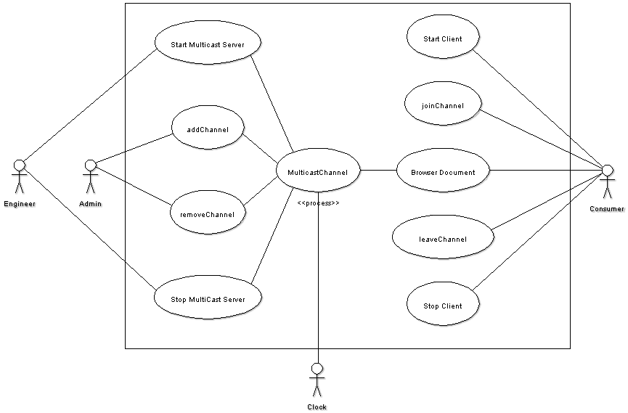

Sequence Diagram

